**CAFÉ ETOILE SALES**

# PROBLEM STATEMENTS

## KPI REQUIREMENTS:

* **Total Sales Analysis**
  + Calculate the total sales for each respective month.
  + Determine the month-on-month increase or decrease in sales.
  + Calculate the difference in sales between the selected month and the previous month.
* **Total Orders Analysis**
  + Calculate the total number of orders for each respective month.
  + Determine the month-on-month increase or decrease in the number of orders.
  + Calculate the difference in the number of orders between the selected month and the previous month.
* **Total Quantity Sold Analysis**
  + Calculate the total quantity sold for each respective month.
  + Determine the month-on-month increase or decrease in the total quantity sold.
  + Calculate the difference in the total quantity sold between the selected month and the previous month.

## CHARTS REQUIREMENTS:

* **Calendar Heat Map:**
  + Implement a calendar heat map that dynamically adjusts based on the selected month from a slicer.
  + Each day on the calendar will be color-coded to represent sales volume, with darker shades indicating higher sales.
* **Sales Analysis by Weekdays and Weekends:**
  + Segment sales data into weekdays and weekends to analyze performance variations.
  + Provide insights into whether sales patterns differ significantly between weekdays and weekends.
* **Sales Analysis by Store Location:**
  + Visualize sales data by different store locations.
  + Include month-over-month (MoM) difference metrics based on the selected month in the slicer.
  + Highlight MoM sales increase or decrease for each store location to identify trends.
    - * **SQL QUERIES on these Problem Statements**
* Created the database and selected it for use.



* Check the contents of the table



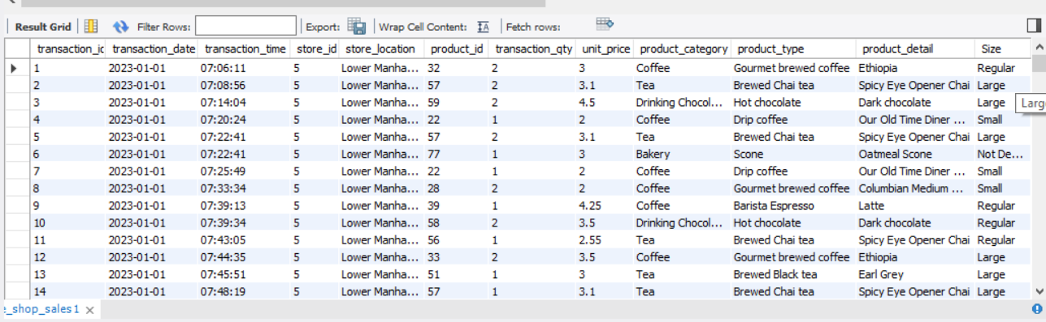

* Let’s see all the data type of the table columns.



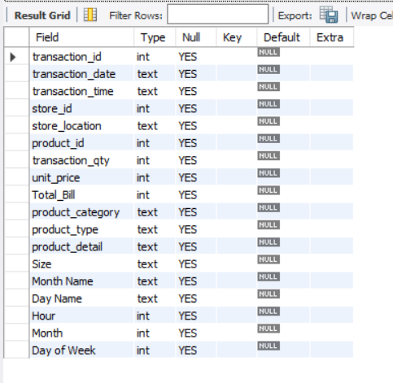

* **CONVERT THE DATE AND TIME COLUMNS INTO PROPER FORMAT**:

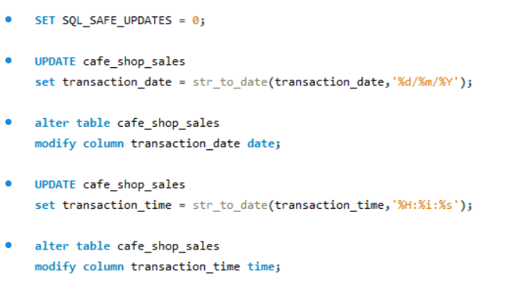

* And now the date and time columns are in appropriate format:

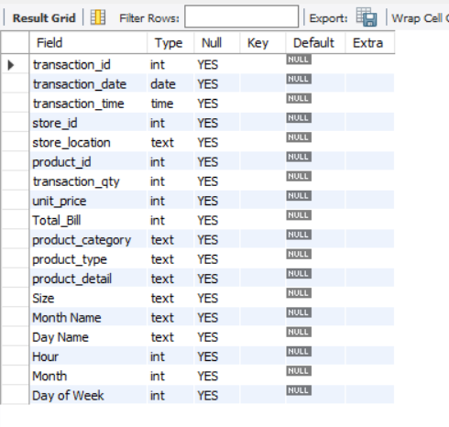

* **TOTAL SALES ANALYSIS:** 
  + **Calculate the total sales for each respective month.**
  + **Determine the month-on-month increase or decrease in sales.**
  + **Calculate the difference in sales between the selected month and the previous month.**

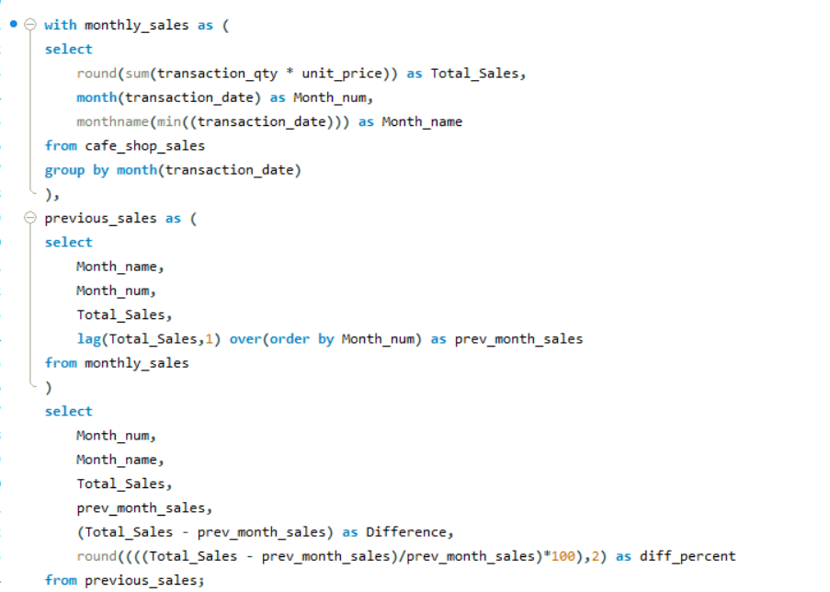

We have the output here for all the **SALES** analysis’ problem statement:

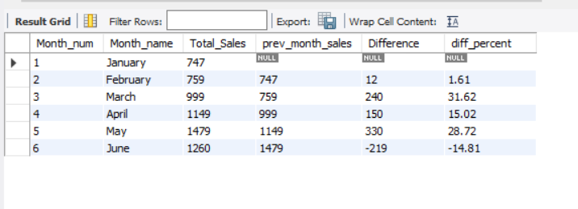

* **TOTAL ORDER ANALYSIS**
  + **Calculate the total number of orders for each respective month.**
  + **Determine the month-on-month increase or decrease in the number of orders.**
  + **Calculate the difference in the number of orders between the selected month and the previous month.**

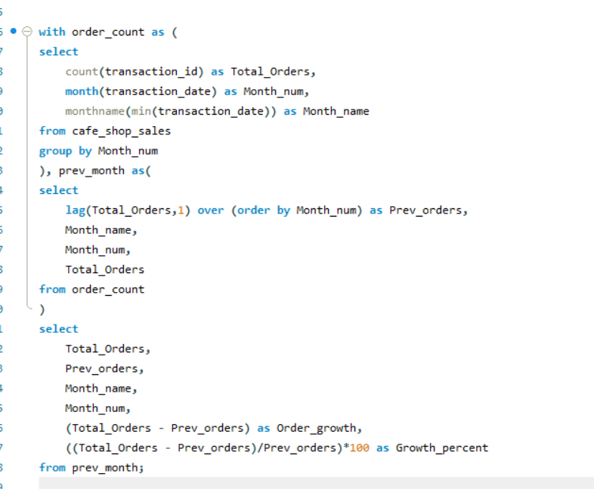

We have the output here for all the **ORDER** analysis’ problem statement:

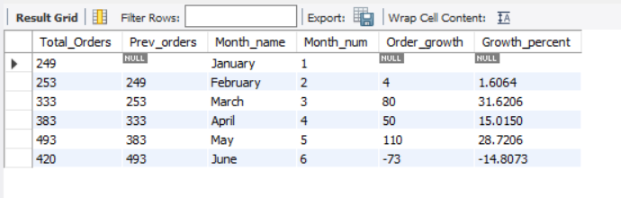

* **Total Quantity Sold Analysis**
  + **Calculate the total quantity sold for each respective month.**
  + **Determine the month-on-month increase or decrease in the total quantity sold.**
  + **Calculate the difference in the total quantity sold between the selected month and the previous month.**

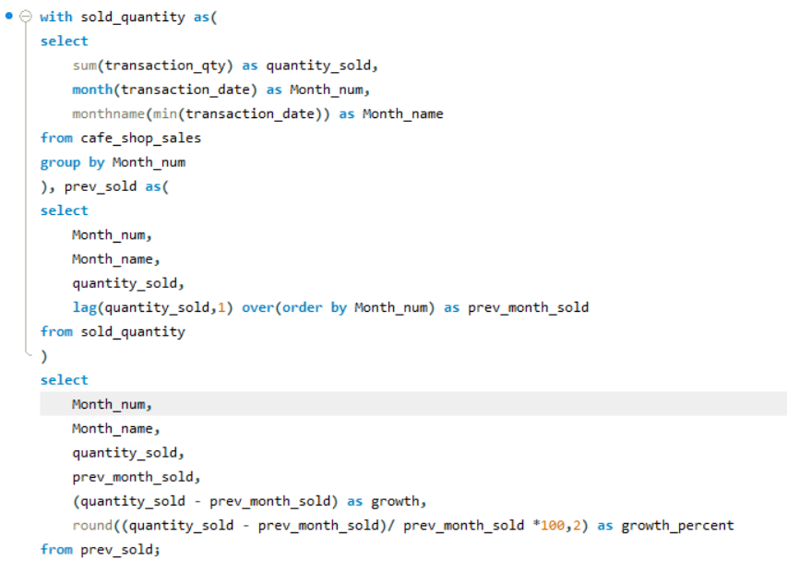

We have the output here for all the QUANTITY SOLD analysis’ problem statement:

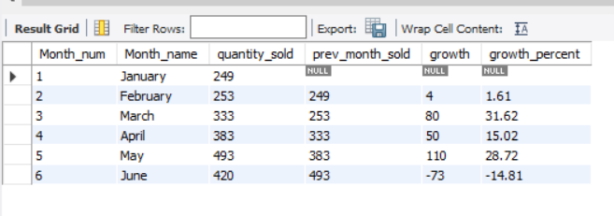

* **Individual date sales, orders and quantity sold:**

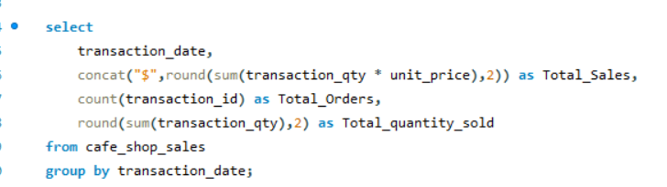

* **Here we only see the output from all the months :**

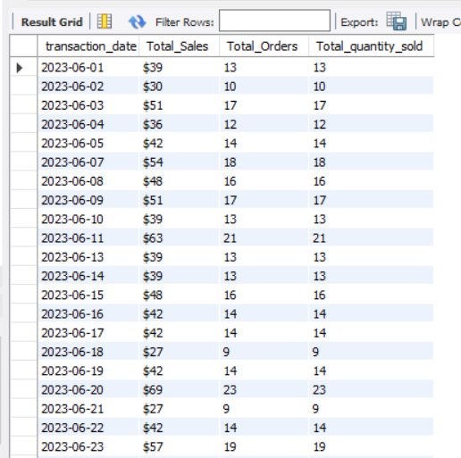

* **If we need any specific month’s data then we can use “WHERE” clause to retrieve the data:**

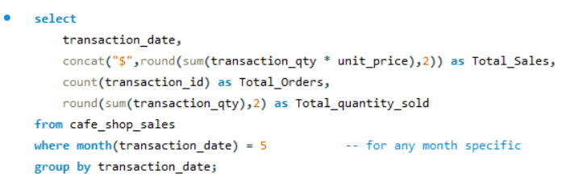

* **Here we can see only the result for the month “May”:**

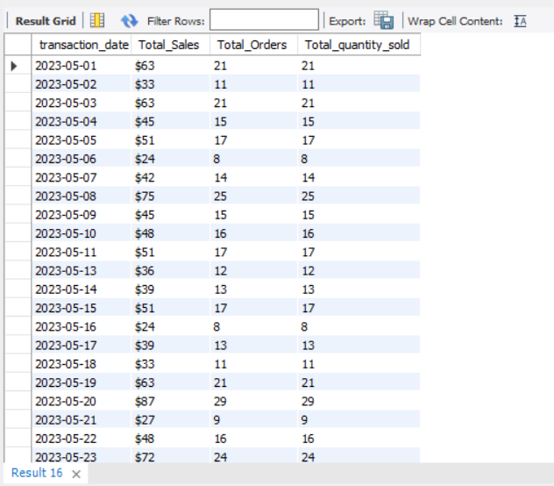

* **WEEKDAY v/s WEEKEND : SALES, ORDERS AND QUANTITY SOLD**

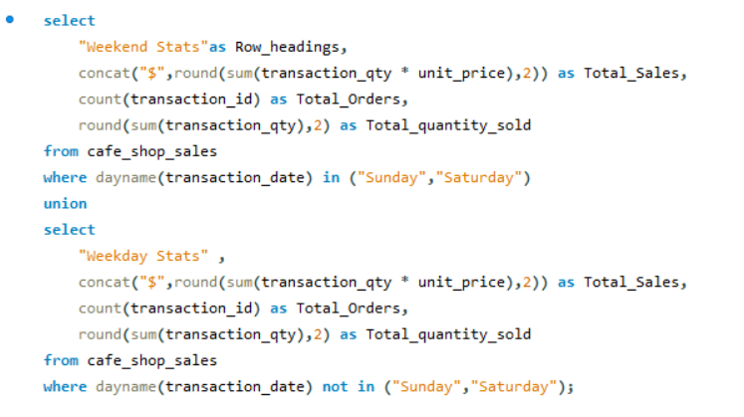

* **We have the below results for the query:**

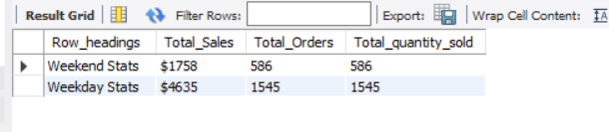

* **Is there any insights we can derive from average sales in weekdays and weekends?**

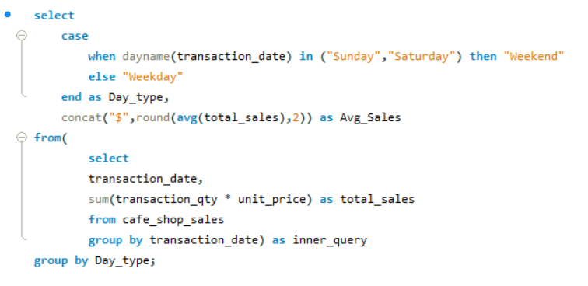

* **The answer is NO, as we can clearly see on an average weekend maybe behind in sales from Weekdays but the difference is not major:**

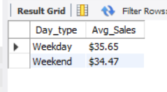

* **Making some Data Manipulation, since we had anomalies in store locations.**



* **STORE LOCATION ANALYSIS MoM Trends:**

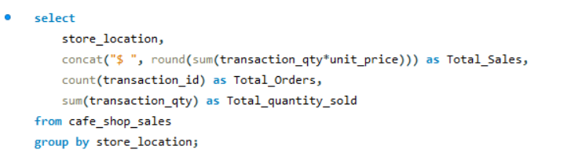

* **Overall stats by different store location**

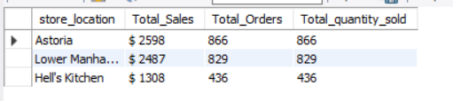

* **MoM trendline in tabular format:**

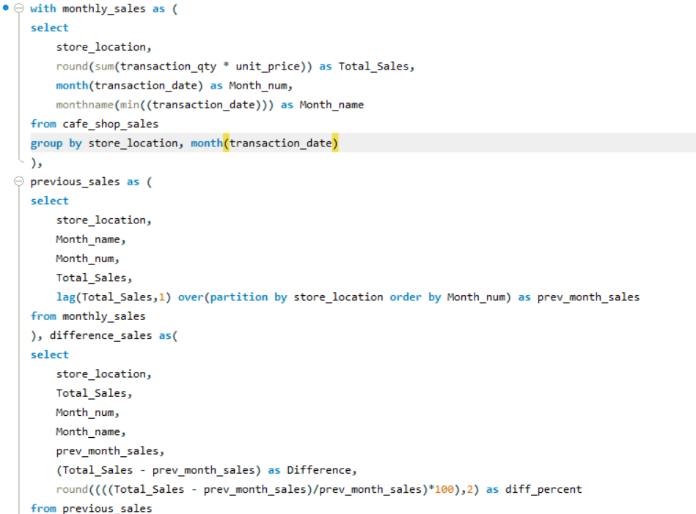 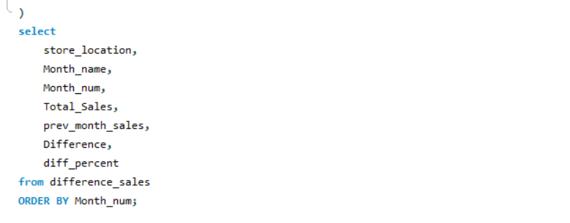

* **Result was:**